EFFECT OF CONTACT TIME AND DOSAGE ON THE REMOVAL OF SELECTED PHYSICOCHEMICAL POLLUTANT FROM HOSPITAL WASTEWATER USING KAOLIN CLAY COMPOSITE
¹Nyong Imoh Edem, ²Lincoln E. Njor
1 & 2 Department of Civil Engineering Technology, Federal Polytechnic Ukana, Akwa Ibom State.
Correspondent: nyongimoh@gmail.com, 08037100227

ABSTRACT
Hospital wastewater contains a complex mixture of physicochemical pollutants that may pose significant environmental and public-health concerns when discharged without adequate treatment. This study investigated the effectiveness of a kaolin clay composite as an adsorbent for the removal of selected physicochemical pollutants from hospital wastewater, with particular emphasis on the effects of contact time and adsorbent dosage. Hospital wastewater samples were collected and characterized for selected physicochemical parameters, including pH, turbidity, electrical conductivity, total dissolved solids (TDS), chemical oxygen demand (COD), and other relevant pollutants. The kaolin clay composite was prepared and applied to the wastewater under controlled laboratory conditions. Batch adsorption experiments were conducted by varying the contact time and adsorbent dosage while maintaining other experimental conditions constant. The results are expected to demonstrate that both contact time and adsorbent dosage significantly influence the adsorption performance of the kaolin clay composite. An increase in contact time is anticipated to enhance pollutant removal until equilibrium is reached, while increasing the adsorbent dosage is expected to provide additional active adsorption sites and consequently improve removal efficiency up to an optimum dosage. The findings will provide useful information on the potential application of kaolin clay based composite materials as a relatively simple for hospital wastewater. The study may contribute to the development of more sustainable adsorption-based approaches for reducing physicochemical pollution and improving the quality of hospital wastewater prior to environmental discharge.
Keywords: Hospital wastewater; kaolin clay composite; adsorption; contact time; adsorbent dosage; physicochemical pollutants; wastewater treatment

INTRODUCTION
Hospital wastewater is a significant source of environmental pollution, containing a wide range of pollutants, including pathogens, pharmaceuticals, and heavy metals (Kümmerer et al., 2009).The treatment of hospital wastewater is crucial to prevent the spread of diseases and to protect the environment. Conventional wastewater treatment methods, such as activated sludge and trickling filters, have several limitations, including low efficiency, high energy consumption, and production of large amounts of sludge (Meh et ,al 2014). Hospitals have an important role in the wellbeing of mankind and other medical research advancements. Different units/services of hospitals require large volume of water according to the activities taking place within the hospitals and generates large amount of wastewater which is an impounding challenge in environmental engineering. Hospital wastewater (HWW) is affected by size (number and type of wards/units), and services provided (kitchen and laundry). A hospital in developed country generates 400 to 1200 L wastewater per bed per day whereas for under developed countries the value is 200 to 400 L/capita/day as compared to 100 to 400 L/capita/day of domestics wastewater generation (Carraro et al 2016). Characteristics of wastewater generated from hospitals are similar to the domestic wastewater, but a proportion of the HWW contains toxic, non -biodegradable, infectious pollutants (Kumar et al 2007). The hospital effluents contain a large variety of substances used for medical, laboratories, research purposes, and also include excreta from patients. These wastes include drugs and their metabolites such as antibiotics, analgesics, antidepressants, organic matters, solvents, metals, disinfectants, specific detergents for endoscopes and other instruments (Kovalova et al., 2012). These pollutants have adverse toxic effect to humans as well as aquatic animals even at very low concentration and termed as biological active substances. These effluents also carry pathogenic microorganisms such as viruses, bacteria, fungi and protozoans which induces pressure of rapid adaptation. Hospitals are known for their excessive and persistent use of antibiotics (Santoro, et al., 2015). To evaluate of contact time and dosage is therefore necessary for establishing the condition under which a kaolin clay composite can achieve effective removal of selected physicochemical pollutants. Determining the optimum contact time, can help establish the period required for adequate pollutant absorbent interaction, while determining the optimum dosage can help identify the quantity of composite required to achieve effective treatment without unnecessary material consumption. The result can also provide information for subsequent adsorption and equilibrium studies and contribution to the design of a more efficient treatment process. Furthermore the contact time and dosage provide essential information for subsequent adsorption and investigation, contact time data can be used to rate the pollutant uptake and established the time required to approach adsorption point, while dosage studies can assist in determining the relationship between the amount of adsorption applied and pollutant removal efficiency(Khan et,.al,2023).These study investigate the effect of contact time and dosage on the removal of selected physicochemical pollutants from hospital wastewater using a kaolin clay composite. It also provides the experimental evidence on how variations in contact time and composite dosage influence pollutant removal, identity appropriate operating condition and contribute to the development of an effective and potentially sustainable clay base treatment approach for hospital wastewater.

MATERIAL AND METHOD

Raw kaolin clay was processed by sedimentation technique to produce clay fractions < 2 µm hydrodynamic diameter, and removal of excess non-clay impurities. Raw kaolin clay lumps of 100 g, 200 g, 300 g and 400 g were dispersed in different containers with 4 litres of Deionized Distilled Water (DDW). These represent 2.5 %, 5 %, 7.5 % and 10 % kaolin clay slurry in DDW.
The raw clays were allowed to swell in distilled water for 24 hours to allow for proper intercalation of the clay structure by water molecules. The resulting clay slurries were stirred for 1 hour using a Heildolph RGL500 High viscosity stirrer at a controlled speed of 40 revolutions per minute for adequate dispersion of the kaolin clay particles in distilled water.
3.0 Activation of kaolin clay
Activation was done by treating the beneficiated kaolin clay (BKC) with 0.5 M of HCl to remove carbonate and the resulting mixture was washed with 10 % H2O2 to oxide organic matter (Bachiri et al., 2014). Filtration of the mixture of acid-activated purified kaolin clay was done using Whatman filter paper. The residue from filtration was washed several times with distilled water and monitored until pH 7 was obtained. This was done to free the suspension of excess acid in the kaolin clay structure.
    - Kaolin clay yield
The kaolin clay yield was calculated using Equation 3.2. Two hundred grams (200 g) each of raw kaolin clay was processed to obtain BKC. The Mass of the activated BKC obtained was measured and the value was substituted in Equation 3.2 to obtain the percentage yield

of the kaolin clay.

𝑌 = 𝑀𝑎𝑠𝑠 𝑜𝑓 𝑃𝑢𝑟𝑖𝑓𝑖𝑒𝑑 𝐾𝑎𝑜𝑙𝑖𝑛 𝐶𝑙𝑎𝑦 𝑃𝑟𝑜𝑑𝑢𝑐𝑒𝑑 X 100% (3.2)
𝑀𝑎𝑠𝑠 𝑜𝑓 𝑅𝑎𝑤 𝐾𝑎𝑜𝑙𝑖𝑛 𝐶𝑙𝑎𝑦

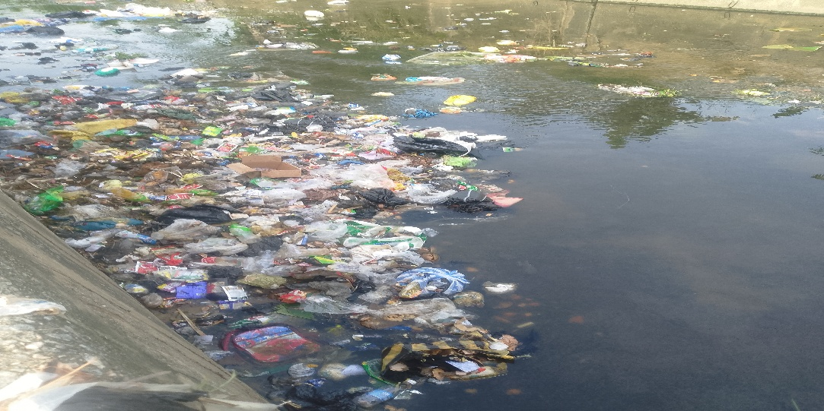
Plate I: Wastewater collection point
3.0.2 Hospital Wastewater Analyses
Hospital wastewater collected via discharge point was analysed to determine the level of contamination and to know precisely the initial physio–chemical and bacteriological characteristics of the hospital wastewater before treatment.
3.0.3 pH
The pH of the domestic wastewater was found to be 8.96 which is basic as shown in Table 4.32. The pH value of the domestic wastewater was above the specified permissible value of effluent discharges, irrigation and reuse standards set by the National Environmental Standard and Regulation Enforcement Agency (NESREA) (2011). The pH of the wastewater was basic and the discharge of this wastewater into waterbodies would be detrimental to zooplankton and fishes, thus affecting their physiology.
3.0.4 Turbidity
The turbidity of the wastewater as analysed was found to be 248 NTU as shown in Table 4.32. Though, no maximum recommended value for turbidity of wastewater in NESREA, 2011, the turbidity of water for human consumption should not exceed 5 NTU and ideally below 1 NTU when compared with Nigerian Standard for Drinking Water
Quality (NSDWQ) (2015). High turbidity will impact aquatic ecosystems by dispersing sunlight and reducing the oxygen concentration. It also affects photosynthesis as well as the respiration and reproduction of fish. It also harbours microorganisms, and therefore the wastewater requires treatment to get rid of turbidity.
3.0.5 Heavy Metals
The obtained analytical results for the iron, cadmium, lead, copper, manganese, arsenic, mercury silver and zinc were found to be 0.83 mg/L, 0.05 mg/L, 0.14 mg/L, 0.05 mg/L, 0.25 mg/L, 0.22 mg/L, 0.11 mg/L, 0.02 mg/L and 2.46 mg/L These listed values were far above the maximum permissible limit set by NESREA (2011). The ability of a waterbody to support aquatic life, as well as its suitability for other uses depends on many trace elements. Some metals, such as manganese, zinc and copper, when present in trace concentrations are important for the physiological functions of living tissue and regulate many biochemical processes. The same metals, however, discharged into natural waters at increased concentrations in sewage, can have severe toxicological effects on humans and the aquatic ecosystem (NWQRL, 2021).

Table 4.32: Wastewater Quality Analysis
Parameters | Units | Wastewater | NESREA (2011)
Odour | - | Smelling
pH | - | 8.96 | 6.5 -8.5
Turbidity | NTU | 248
EC | µS/cm | 1382
Dissolved Oxygen | mg/L | 1.00 | 4 (Min)
TSS | mg/L | 233 | 0.75
TDS | mg/L | 926
Colour | TCU | 1620
Nitrate | mg/L | 230 | 40
Phosphates | mg/L | 11.8 | 3.5
Ammonium | mg/L | 37.2 | 2.0
Chloride | mg/L | 133 | 350
COD | mg/L | 312 | 30
BOD5 | mg/L | 30.6 | 6
Oil and Grease | mg/L | 10.1 | 0.1
Sodium | mg/L | 29.0 | 120
Potassium | mg/L | 23.0 | 50
Cadmium | mg/L | 0.01 | 0.01
Total Iron | mg/L | 0.83 | 0.5
Lead | mg/L | 0.14 | 0.1
Copper | mg/L | 0.05 | 0.01
Manganese | mg/L | 0.25
Arsenic | mg/L | 0.22 | 0.05
Chromium (Cr⁺⁶) | mg/L | 0.04 | 0.5
Mercury | mg/L | 0.11 | 0.0005
Silver | mg/L | 0.02
Zinc | mg/L | 2.46 | 0.2
Total Coliforms | cfu/100ml | 6.45 x 10³ | 5 x 10³
E. coli | cfu/100ml | 400 | Absent
Faecal Coliforms | cfu/100ml | 640 | Absent
Clostridium perfringens | cfu/100ml | 48 | Absent

RESULT AND DISSCUSSION

This section presents the results of the treatment of hospital wastewater using the synthesized BKC adsorbents. The adsorbents were employed to reduce the concentrations of selected pollutants in the wastewater to acceptable levels prior to discharge into the receiving water bodies. The effects of key operational parameters, including contact time, temperature, and adsorbent dosage, on the removal efficiency of pollutants from hospital wastewater collected and investigated. The results obtained from these experiments are presented and discussed in this section.
  - Characterisation of Raw and Beneficiated Kaolin Clay (BKC)

    - XRD analysis

The phase purity and crystallinity of raw and beneficiated kaolin clay were examined by X–ray diffraction (XRD) technique and the results are presented and discussed in this section.
      - XRD analysis of raw kaolin clay

XRD diffractograms of raw kaolin clay displayed the existence of four crystalline phases of kaolinite – Al (Si2O5) (OH)4, kaolinite 1Md – AlSi2O5(OH)4, quartz – SiO2 and muscovite – KAl2 (Si3Al) O10(OH)2. The identified phases were chemically identical, but their atoms were arranged differently except for muscovite which contained potassium as shown in Table 4.4. The dominant impurity compound in the raw kaolin clay was quartz with 66.41 % as shown in Table 4.4.

Table 4.4: XRD Phase Identification of Raw Kaolin Clay

Phases | Formula | Percentage (%)
Kaolinite | Al (Si2O5) (OH)4 | 14.10
Kaolinite 1Md | AlSi2O5(OH)4 | 15.04
Quartz | SiO2 | 66.41
Muscovite | Kal2(Si3Al) O10(OH)2 | 4.45

Interplanar spacing between the parallel planes of atoms in raw kaolin clay was gotten to be 3.4994 nm at Scherrer’s constant of 0.94 and wavelength (λ) of 1.5406 Å in Table 4.5.

Table 4.5: Interplanar Spacing and Crystallite Size of Raw Kaolin Clay

Diffraction Angle, 2θ | d- spacing, (nm) | FWHM of the Intense Peak, β, (radians) | Crystallite Size, D, (nm)
12.2860 | 7.2203 | 0.25190 | 33.129
24.8213 | 3.5950 | 0.32526 | 26.120
26.5769 | 3.3613 | 0.15880 | 53.688
50.0630 | 1.8258 | 0.14218 | 64.408
62.2406 | 1.4945 | 0.40475 | 23.946
Average | 3.4994 |  | 40.258
The average crystallite size for the raw kaolin clay was calculated to be 40.258 nm, while the average crystalline size diameter was calculated to be 40.258 nm. These two calculated parameters clearly showed that the raw kaolin clay is polycrystalline. The best peaks produced were selected and the Full Width at Half Maximum (FWHM) of the intense peak was calculated. The FWHM ranged from 0.1588 – 0.40475 radians. The XRD pattern showing various peaks produced is presented in Figure 4.1 (A). The broad and multiple peaks formation of the XRD pattern in Figure 4.1 (A) and (B) showed that both the raw and beneficiated kaolin clay were polycrystalline. Multiple peaks were detected for each phase between 5.077° to 85.049°. The dominant compound in the beneficiated clay was quartz. Inter-atomic spacing between the parallel planes in the BKC was calculated to be 3.532 nm. The average crystallite size for the BKC was also calculated to be 28.114 nm at Scherrer’s constant of 0.94 and wavelength (λ) of 1.5406 Å as presented in Table 4.6. The best peaks produced were selected and the Full Width at Half Maximum (FWHM) of the intense peak was calculated. The FWHM ranged from 0.1825 – 0.5118 radians. The broad peak formation of the XRD pattern showed that the beneficiated clay was polycrystalline.

Table 4.6: Interplanar Spacing and Crystallite Size of Beneficiated Kaolin Clay

Diffraction Angle, 2θ | d- spacing, (nm) | FWHM of the Intense Peak, β, (radians) | Crystallite Size, D, (nm)
12.2966 | 7.2142 | 0.3106 | 26.869
24.8279 | 3.5940 | 0.3225 | 26.348
26.5858 | 3.3602 | 0.1825 | 46.714
45.5049 | 1.9975 | 0.5118 | 17.580
62.2534 | 1.4942 | 0.4203 | 23.060
Average | 3.532 |  | 28.114

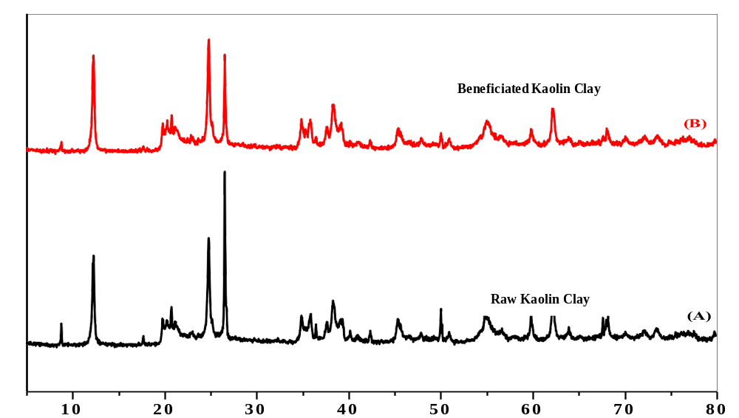
Figure 4.1: XRD Patterns of (A) Raw kaolin and (B) Beneficiated Kaolin

4.0.2 Effect of contact time on physical parameters
Figure 4.3 (a – e) describes the effect of contact time on the removal of turbidity, suspended solids, colour, EC, improvement of pH and dissolved oxygen using BKC adsorbents.
The effect of contact time on the removal of turbidity, suspended solids, colour, EC and improvement of pH and dissolved oxygen of the wastewater during treatment with BKC adsorbents was studied at a contact time of 10, 20, 30, 40, 50 and 60 minutes using an adsorbent dosage of 25 g/100 mL of wastewater at a temperature of 29.5 °C and pH of 6.9.
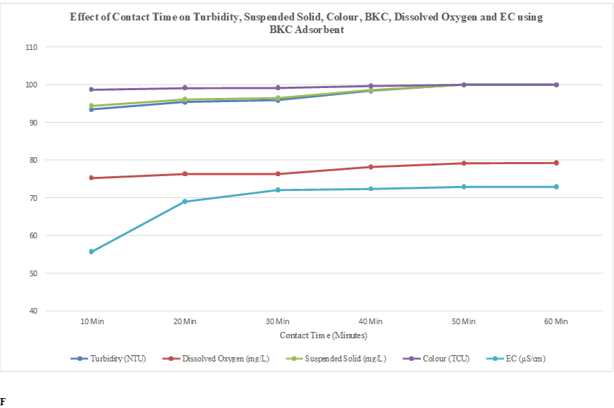

CONCLUSION AND RECOMMEDATION
5.0.1 The study supports the use of kaolin clay as a potentially accessible and relatively inexpensive adsorbent for improving the physicochemical quality of hospital wastewater. Nevertheless, kaolin adsorption should preferably be viewed as a treatment or polishing step within an appropriate wastewater-treatment train rather than as a universal substitute for biological, chemical, or advanced treatment processes, consideration is that hospital wastewater is chemically complex. Organic matter, dissolved salts, suspended solids, pharmaceuticals, disinfectants, and other constituents can compete for adsorption sites. Therefore, performance obtained under controlled laboratory conditions may differ from that obtained with wastewater of varying composition. The kaolin dosage generally provides a greater number of available adsorption sites and a larger effective surface area for pollutant uptake. Consequently, pollutant removal is expected to improve as the kaolin dose increases, particularly at lower dosages where adsorption sites are initially insufficient. However. Therefore, the optimum kaolin dosage should be determined experimentally rather than assuming that the highest dosage will always produce the best treatment.
Recommendations
1.Determine an optimum kaolin dosage, rather than continuously increasing the adsorbent concentration, experiments should identify the dosage at which further addition produces only limited improvement in pollutant removal.
2. Contact-time experiments should be used to determine the point at which adsorption approaches equilibrium. Operating beyond this point should be avoided unless the additional removal justifies the increased treatment time.
3.The optimum condition should be based on the combined effect of dosage and contact time, rather than selecting the highest dosage and longest contact time independently.
REFERENCES
Bachiri, E. M., Akichouh E., Miz, H., Salhi, S., & Tahani, A. (2014). Adsorptions desorption and kinetics studies of Methylene Blue Dye on Na-bentonite from Aqueous Solution. Journal of Applied Chemistry, 7(7), 60-78.
Carraro, E., Breschigliaro, S., &Musiani, M. (2016). Hospital wastewater treatment: A review of the current situation and the potential application of membrane bioreactors. Environmental Science and Pollution Research, 23(1), 331-346. doi: 10.1007/s11356-015-5374-5
Kümmerer, K. (2009). Antibiotics in the aquatic environment—A review. Chemosphere, 75(4), 417– 434.
Kümmerer, K., Helmers, E., &Hubner, P. (2007). Hospital effluents as a source of platinum in the environment. Environmental Science and Pollution Research, 14(5), 331-336. doi:
10.1065/espr2007.02.372
Kovalova, L., Siegrist, H., & von Gunten, U. (2012). Hospital wastewater treatment by membrane bioreactors: A review. Environmental Science and Pollution Research, 19(8), 3121-3133. doi:
10.1007/s11356-012-0949
Khan, S.,Ajimal, S., Hussain, T.,(2023). Clay-based material for enhanced water treatment;Adsorption mechanism, challenges, and future direction.journal of umm AL-Qura.
Mehmood, A., Murtaza, G., Bhatti, T. M., Raffi, M., & Kaiser, R. (2014). Removal of Cr(III) and Cr(VI) through adsorption and membrane filtration from synthetic and real wastewaters. Journal of Pharmaceutical Sciences and Innovation, 9(4), 238-245
National Environmental Standards Regulations and Enforcement Agency (NESREA) (2011). National environmental (surface and groundwater control) regulations, 2011. Federal Government Printer, Lagos, Nigeria. FGP71/72011/400 (OL,46).

National Water Quality Reference Laboratories (NWQRL) (2021). Rivers and open waterbodies monitoring activities report of 2021, Water Quality Control and Sanitation Departments, Federal Ministry of Water Resources, Abuja.
Nigeria Standard or Drinking Water Quality (NSDWQ) (2015). Nigeria Industrial Standard, Standard Organisation of Nigeria. ICS 13.060.20. Retrieved from https://africacheck.org/sites/default/files/Nigerian-Standard-for-Drinking-Water-Quality-NIS-554-2015.pdf, 25th March, 2023.

Santoro, D., Gehr, R., & Li, L. (2015). Treatment of hospital wastewater: A review. Environmental
Science and Pollution Research, 22(1), 1-13. doi: 10.1007/s11356-014-3754-7

